Are the following True, False or Uncertain? Please provide explanations for your responses.

In a regression study of electricity demand the price response was found to be insignificantly different from zero. Therefore price is not an important determinant of electricity consumption.

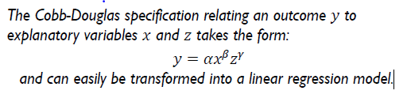
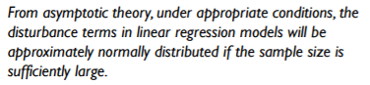

How do you calculate p-values? How do you read the table?

How do you calculate confidence intervals? Are they always taken at 95%?

Please and thanks!

